Please follow instructions here to access webcam from MATLAB:

<http://au.mathworks.com/help/supportpkg/usbwebcams/ug/installing-the-webcams-support-package.html>

If you’re unable to access webpage above then please follow the instructions given below

**Installing the Support Package**

1. In MATLAB type:

supportPackageInstaller

to open the Support Package Installer. You can also open the installer from MATLAB by selecting **Home > Environment > Add-Ons > Get Hardware Support Packages**.

1. On the **Select an action** screen, select **Install from Internet**, and click **Next**. This option is selected by default. Support Package Installer downloads and installs the support package and third-party software from the Internet.

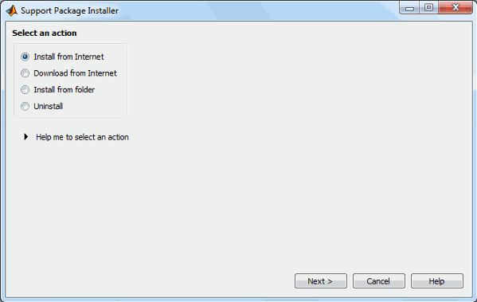

1. On the **Select support package to install** screen, select USB Webcams from the list.

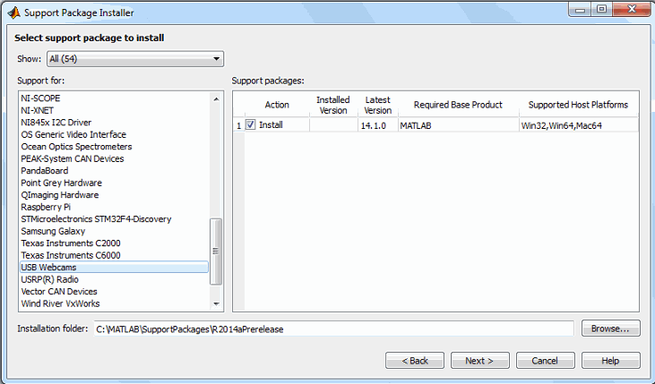

Accept or change the **Installation folder**, and click **Next**.

**Note:**   You must have write privileges for the Installation folder.

1. If you are prompted to log in to your MathWorks® account, click **Log In** to continue. User your Unimelb student ID.
2. On the **MATHWORKS AUXILIARY SOFTWARE LICENSE AGREEMENT** screen, select the I accept check box, and click **Next**.
3. On the **Confirm installation** screen, Support Package Installer confirms that you are installing the MATLAB Support Package for USB Webcams, and lists the installation location. Confirm your selection, and click **Install**.

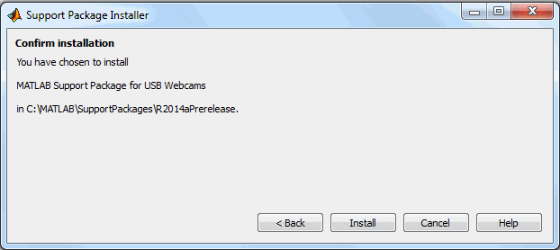

1. Support Package Installer displays a progress bar while it downloads and installs the Webcam support package.
2. After the installation is complete, you will see a confirmation message on the Support Package Installer **Install/update complete** screen. Click **Finish** to close the Support Package Installer.
3. If you selected the **Show support package examples** option (recommended), Help displays the example.